**Dataset Preparation:**

I have taken multiple drone videos and converted them to images and marked the drone in those images. I have used LabelImg tool (<https://github.com/tzutalin/labelImg>) for this task.

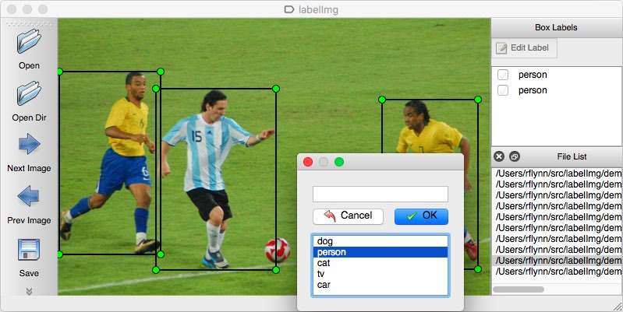

So by this method we have marked the drone images like shown below:

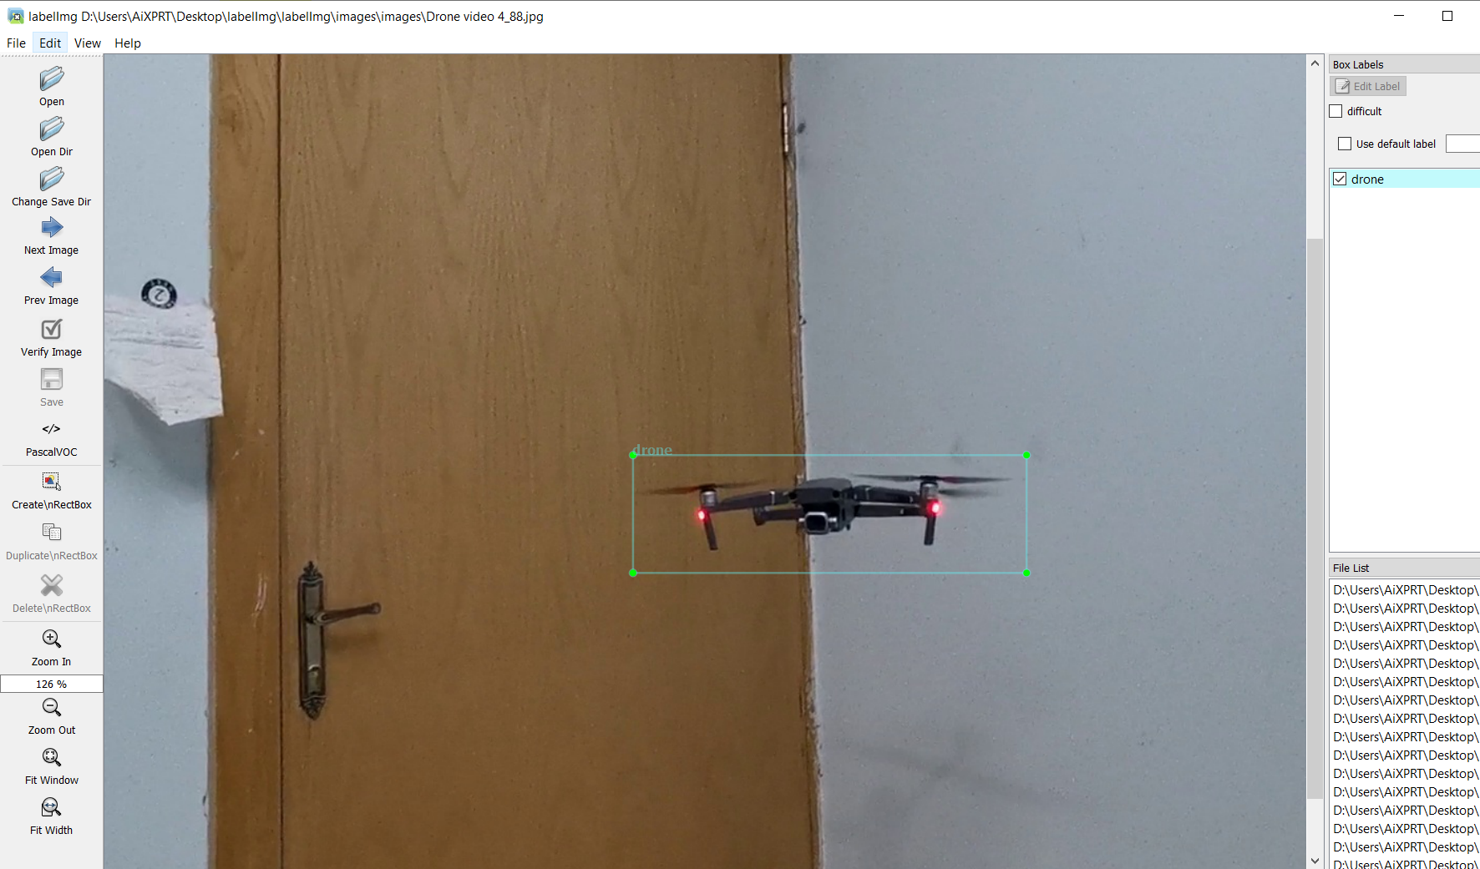

So far we have marked around 700 unique images of drones.

**Object detection model:**

There are multiple types of object detection model architecture available these

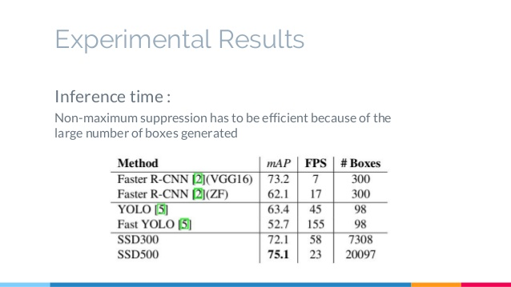

So what we are trying is to choose the best model, based on mAP (mean Accuracy precision) and FPS values. So according to this map yolo is quite fast but it has less accuracy. So we have choose ssd300 for our task to get high mAP with high frame rate. By this way we will be able to run it real time.

Source: <https://www.slideshare.net/xavigiro/ssd-single-shot-multibox-detector>

**Tensorflow Object Detection Api for SSD model Training:**

Source: <https://github.com/EdjeElectronics/TensorFlow-Object-Detection-API-Tutorial-Train-Multiple-Objects-Windows-10>

Source: <https://www.youtube.com/watch?v=eJcIntjgCbQ>